**Assignment #2 Report – EigenFaces, Adaboost, Detection**

**Written By: mhtay**

**P1)**

(p1_v3.m)

Eigen-Face was computed from the corpus of images, and the mean and divided by subsequent zero-mean variance to obtain the normalized Eigen-face:

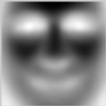

Figure : Eigen-Face

The dot product of the normalized eigen-face was taken against the image, cornered at every pixel of the image except the corners using a sliding window.

The maximum values of the dot product can be seen in an image of the scores obtained.

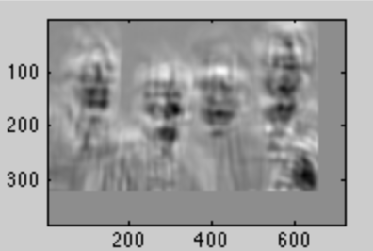

Figure :DotProductImage

However, due to the high intensity of features like the hand, false positives is possible. Thus, a normalized dot product of the faces with the eigenface might produce better results, by not only subtracting the mean of the patches, but also dividing by the sum of each zero mean patch. The resulting score is more informative as the brighter regions correspond to patches cornered at that area.

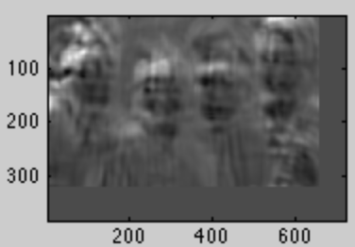

Figure :Zero-Mean, 1 variance patches dot product

Dividing each zero mean patch with the sum of the patch before the mean normalization, however, gives better distinction of the faces:

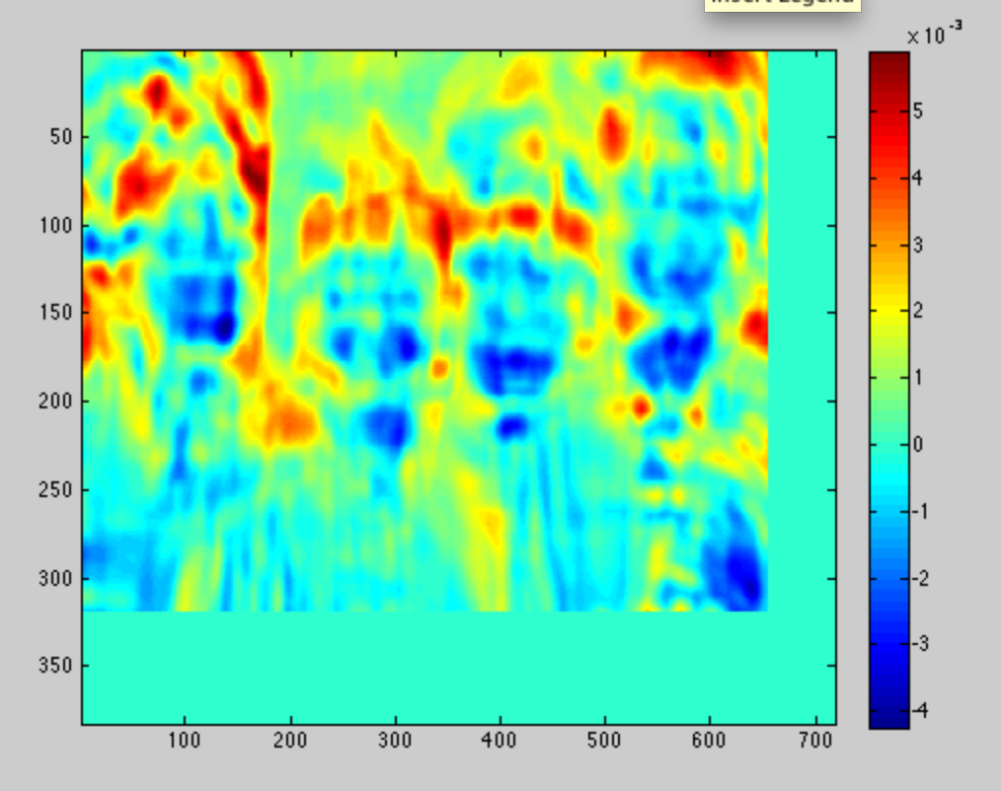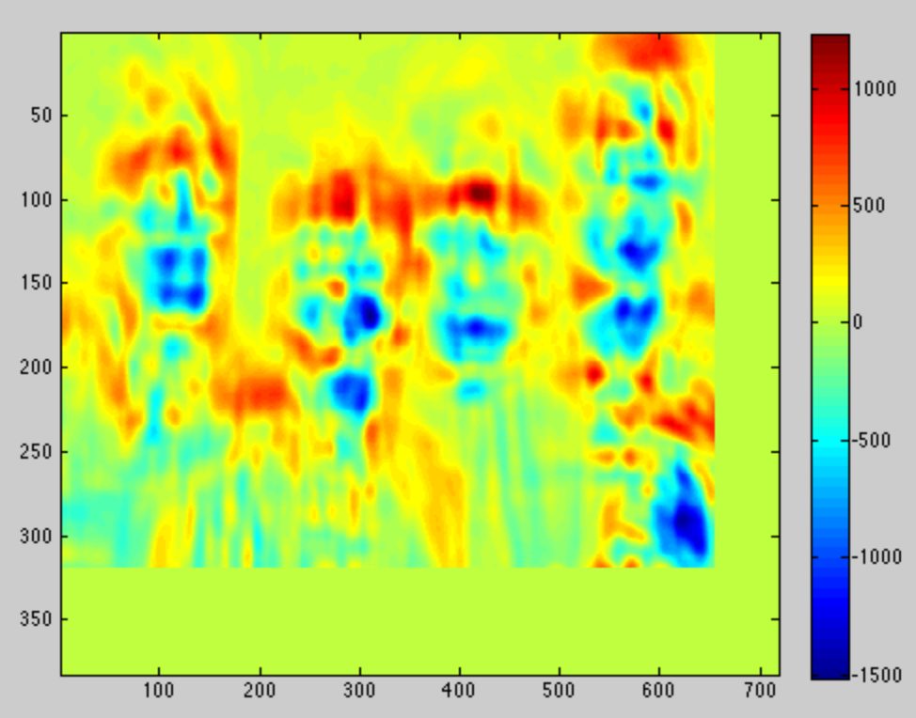

Figure 5: After dividing by sum of patch (before mean norm)

Figure :Without dividing by sum

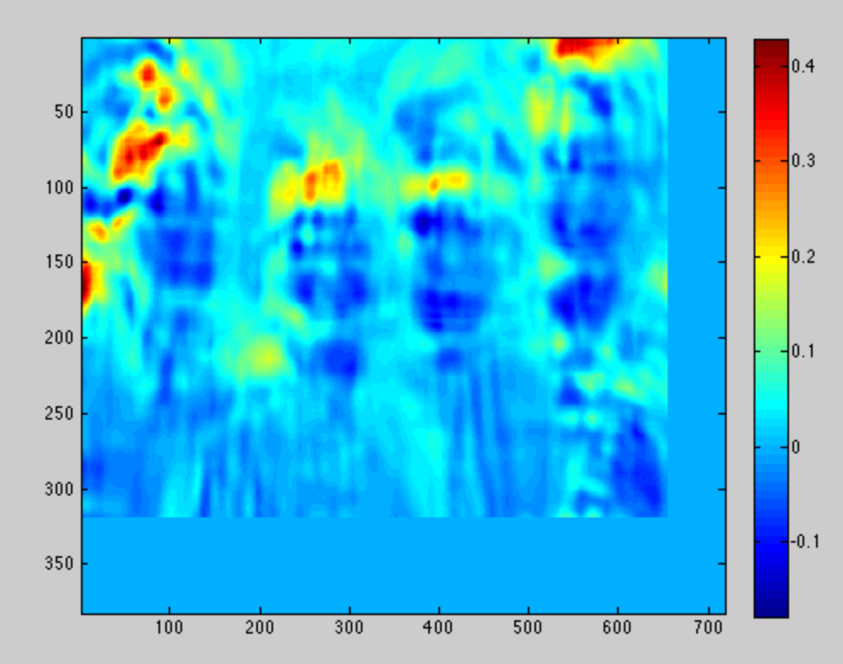

Figure 6: after dividing by sum of mean norm patch

However, the approach taken in figure 6 does not work well on the other image, so the approach was taken to carry out the normalized dot product on each patch after subtracting the patch mean and without dividing by norm, using the eigenface learned after mean and standard deviation normalization.

A query sliding face window, which indicated a 1 in the presence of a face, and 0 otherwise was carried out. The decision on whether a face was present was based on a threshold that was empirically found to be 70% of the maximum patch score.

This was repeated at each of the 5 scales, from a value of 0.5, 0.75, 1.0, 1.5 and 2.0. The resulting faces were detected at:

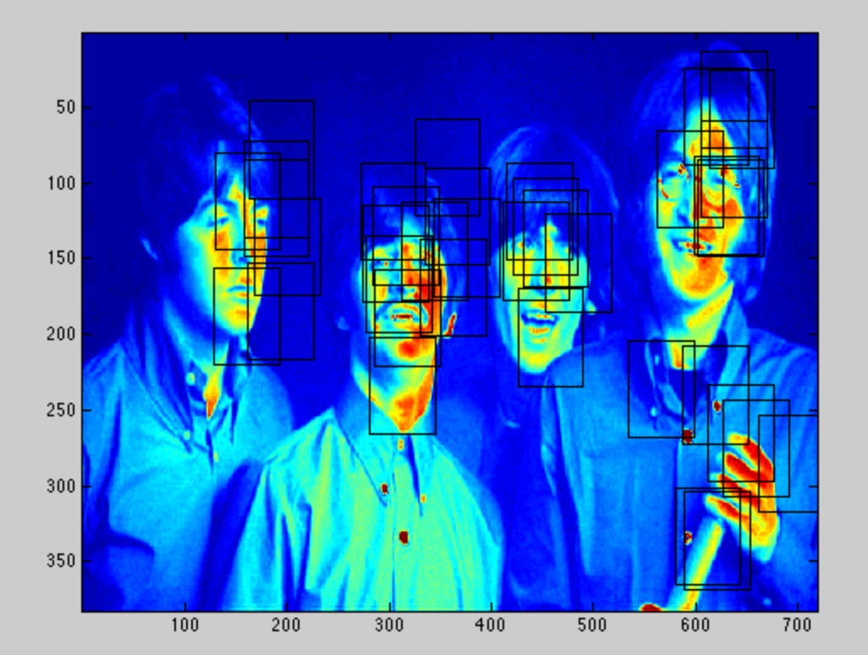

Figure 7: Multi-scale sliding window face query

Thereafter, bounding boxes in proximity were coalesced into a single bounding box. This was done by searching for the nearest bounding box to the existing box, then taking the average of the 2 boxes as the new box. However, the new box produced might be close to an existing box in the shortlisted list, thus the process of searching for nearest boxes needs to be repeated until no closest boxes are found. The limit for the closest box is set to 64, the approximate size of the Eigen-face rectangle.

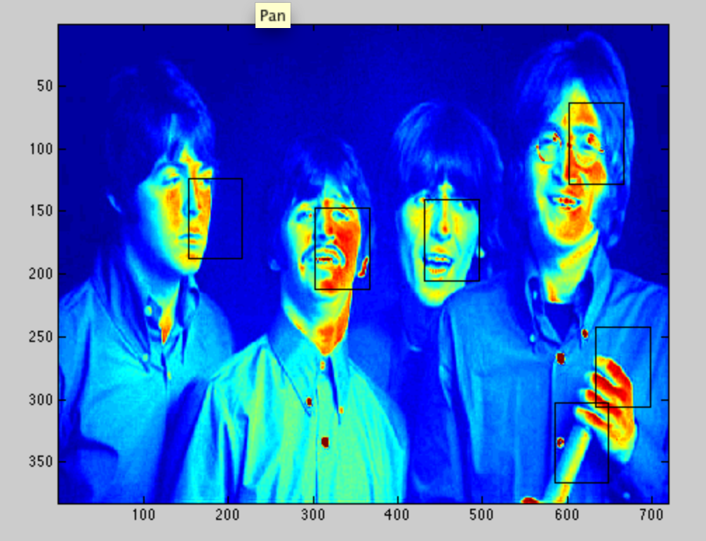

Figure 8: Short-listed faces

Repeating the Process on the other images:

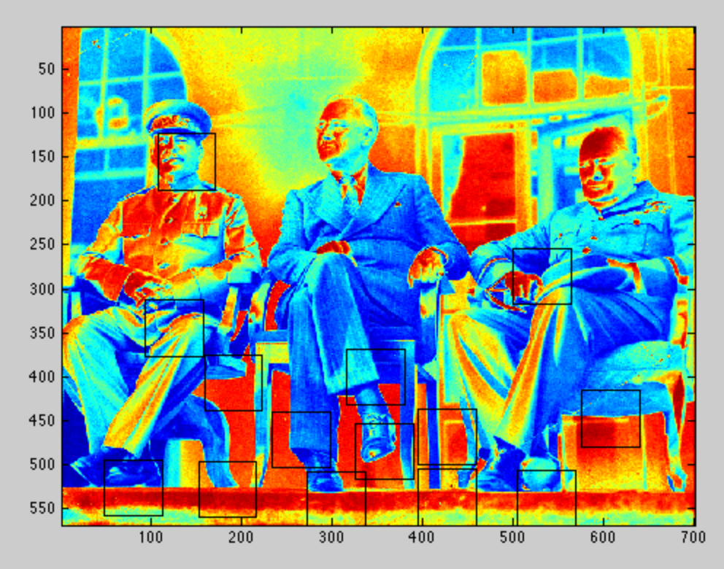

Figure 9:Russian gathering photo

The faces that are turned away from the camera are not well detected, as the training data are all faces that are looking directly at the camera. (front-profile)

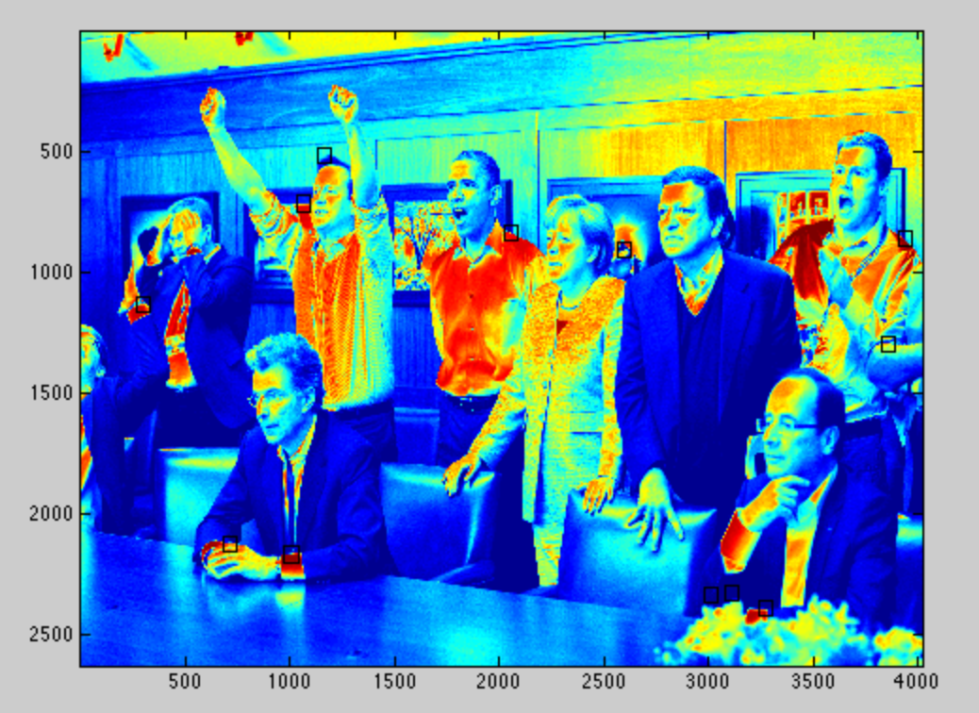

Figure : Group meeting after operation mission success

**P2)**

(p2.m)

Initially, we created a naïve bayes classifier to be used in conjunction with adaboost for classification. The weighted values were incorporated into the classifier such that more highly weighted values were given higher counts and hence higher probability. However, the probability of observing a feature was the sum of all the observed features, and it was a problem since the feature values could be positive and negative and thus sum to 0, thus multiple different feature sets could be read as the same value in this version of the naïve bayes classifier. A train accuracy of 65% was obtained.

Thereafter, a switch was made to the stump classifier to be used as the weak classifier. A stump is a vector of values for a certain feature. In this case, each feature is the weights the dot product of an image with an Eigen-face vector. There are K feature stumps, each corresponding to an Eigen-face. The stump classifier could accommodate both negative and positive values of the feature sets, and worked by making a prediction based on the best threshold and direction that could make a prediction that minimized the weighted error of the training data. The best threshold and corresponding error was recorded for all the stumps, and the best stump was chosen as the weak classifier for the t-th iteration of adaboost.

The final classifier was constructed by adaboost, by a weighted sum of the different weak classifiers learnt.

The number of feature vectors K, was varied from 2 to 16, while fixing the number of weak classifiers at 20. This was done in (p2_findingK.m) The train and test accuracy were then computed. Here the train data is made up from the corpus of labeled face and non-face images, while the test data is made up from a separate corpus of labeled face and non-face images.

|  |  |  |  |  |  |  |  |  |
| --- | --- | --- | --- | --- | --- | --- | --- | --- |
|  | K=2 | K=4 | K=6 | K=8 | K=10 | K=12 | K=14 | K=16 |
| Train Accuracy(%) | 80.75 | 90.51 | 91.47 | 91.57 | 90.94 | 91.54 | 91.54 | 91.50 |
| Test  Accuracy(%) | 62.62 | 74.28 | 79.53 | 80.75 | 79.04 | 81.09 | 81.09 | 81.10 |

Using K=12, the number of weak classifiers was varied from range of 50 to 300. This was done (in p2.m), while manually changing the value of T (in adaboost_train.m). In general, the larger the number of weak classifiers, the better the train and test accuracy, but the longer the time it takes to train the classifier. The incremental improvements has slowed considerably from 200 to 300 classifiers.

|  |  |  |  |  |
| --- | --- | --- | --- | --- |
|  | T=50 | T=100 | T=200 | T=300 |
| Train  Accuracy(%) | 92.93 | 94.3 | 95.1 | 95.4 |
| Test  Accuracy(%) | Overall:82.81  Face: 57.6  NonFace:83.3 | Overall: 84.6  Face: 59.5  NonFace:85.1 | Overall:86.1  Face:60.4  Nonface:86.1 | Overall:86.3  Face:59.5  NonFace:86.3 |

Using the best set of parameters learnt, the best classifier learnt using the train and test data was then scaled to different scales of Eigen-faces. These correspond to the faces at scales of 0.5, 0.75, 1.0, 1.5 and 2.0 respectively.

The stumps were then trained using the scaled versions of the original eigenfaces. This was done by scaling each of the face training data to a different size, concatenating all of the train data and then computing the eigenface at the respective scale. This was done in (p2_findingRescaled.m). The train accuracies were recorded below, and the stump classifier attributes were stored in (multi_scale_T300K12.mat).

|  |  |  |  |  |  |
| --- | --- | --- | --- | --- | --- |
| Scale | 0.5 | 0.75 | 1.0 | 1.5 | 2.0 |
| Train Accuracy (%) | 94.15 | 94.97 | 95.36 | 95.61 | 95.41 |

**P3)**

(p3.m)

The faces in the boosting data were trained using the best set of parameters known K=12 and T=300. In addition, during the training, the normalized error between the reconstructed faces and the actual faces was used as an additional feature (in getEigenFacesIncError.m).

The results are a train accuracy of 96.9% and a test accuracy of 86.47%, improving on the best results obtained from problem 2. (Code in p3.m). The test accuracy for the faces in the test data has also improved to 61.65% and the accuracy for non-faces has improved to 86.96%. Results have also been stored in p3accuracies.mat.

**P4)**

(p4_code.m)

The trained adaboost classifier operated on eigenfaces of size 19x19, thus are different than the usual 64x64 images used to test for faces in the group photos earlier. However, to revert to retraining the adaboost classifier using the eigenfaces from the 64x64 dataset in order to get eigenfaces of 64x64 to test the images against would forgo the large training data of non-faces available in the boosting data. Thus, the image patches to test against was changed to 19x19, and the adaboost classifier was then run against each image patch.

The resulting adaboost classification, before the sign test was applied at T=300, K=12, training data from BoostingData

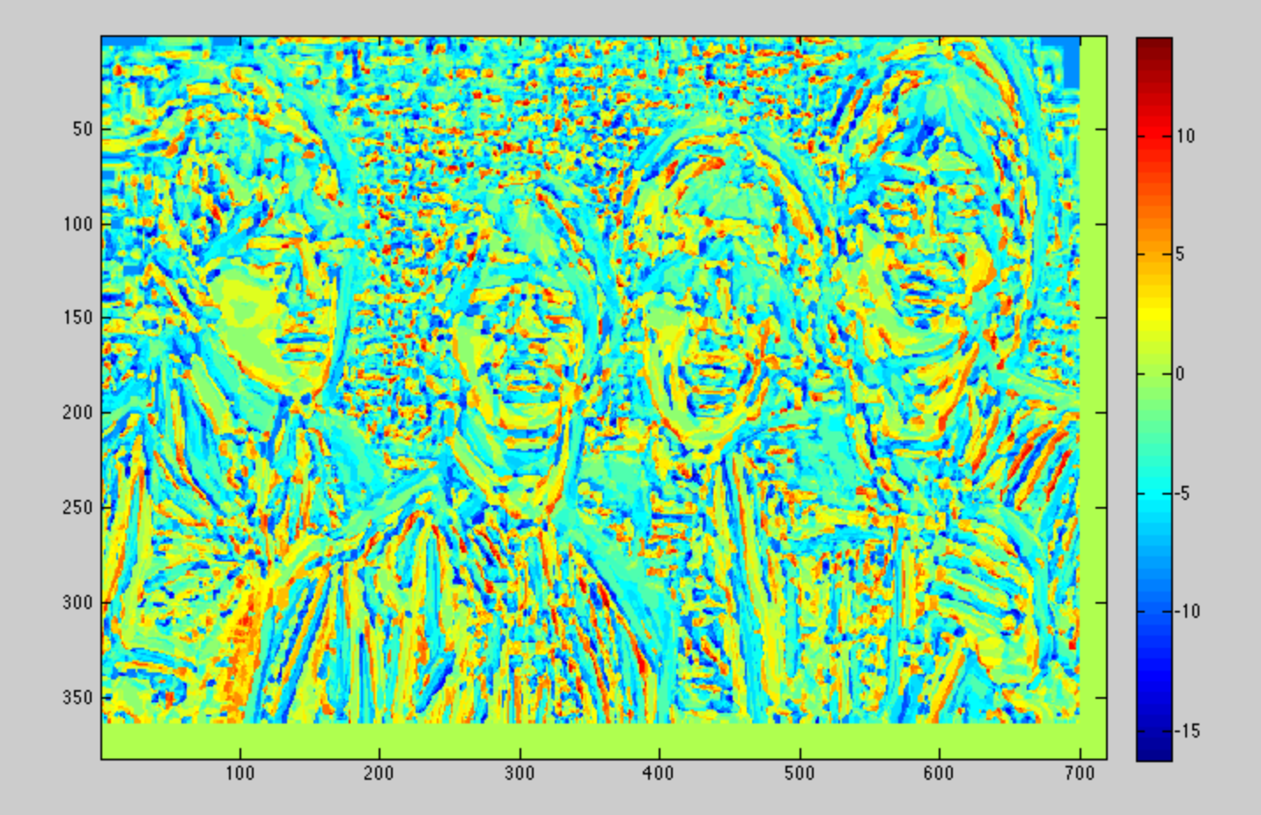

The threshold for the sign test was then applied, at different values for the threshold H(X):

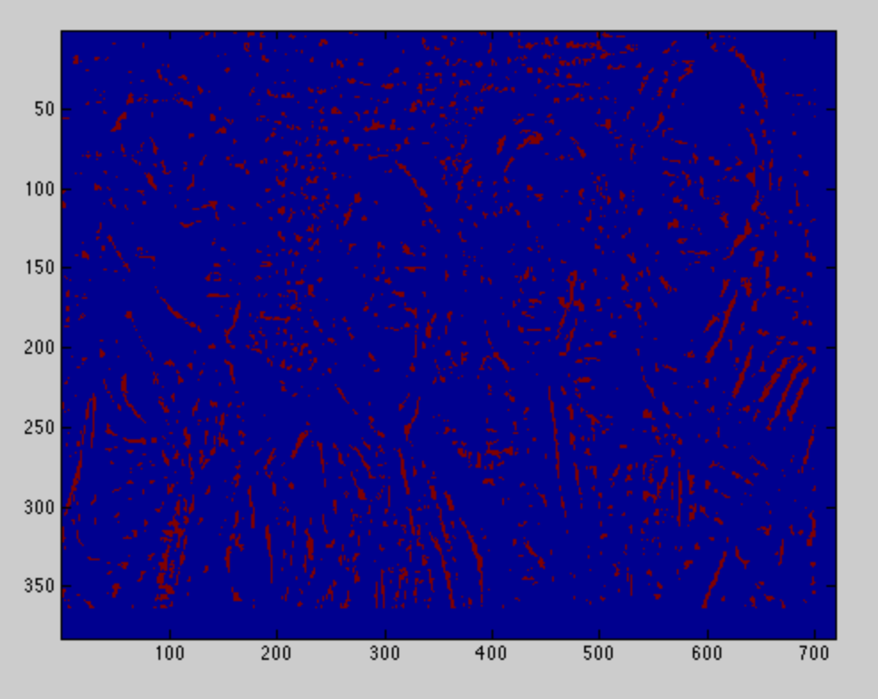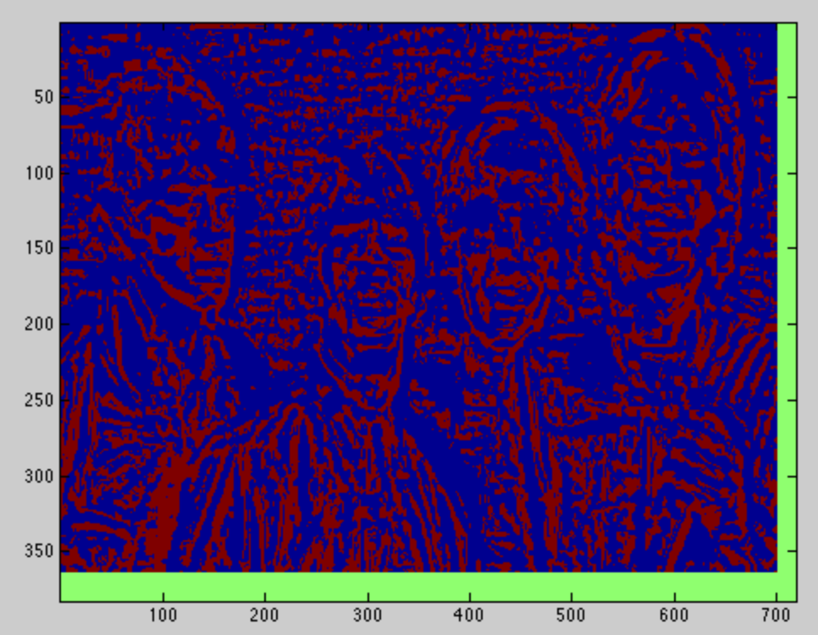

H(X) = 5

H(X) = 0

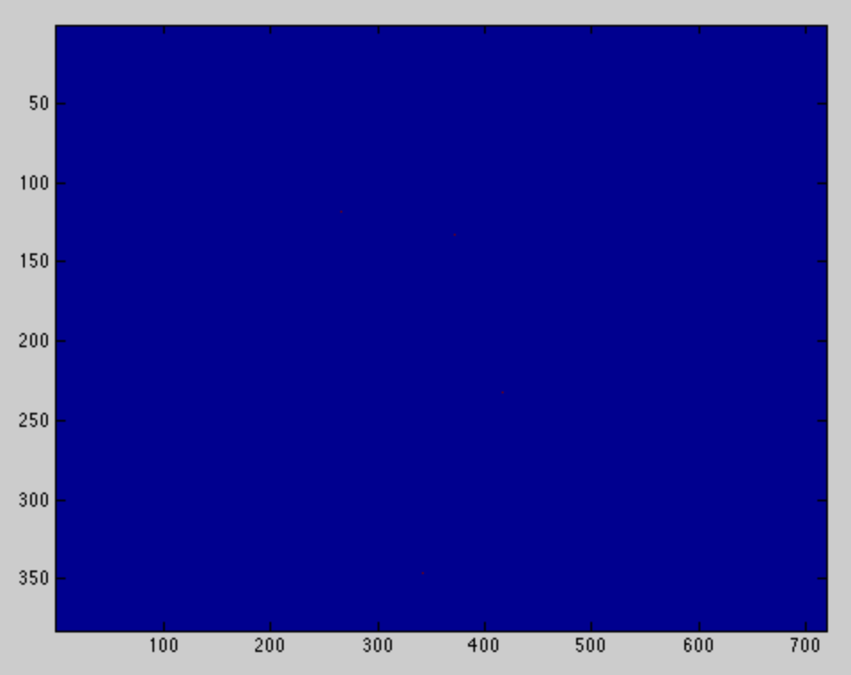

H(X) = 0.9*maximum_value_observed

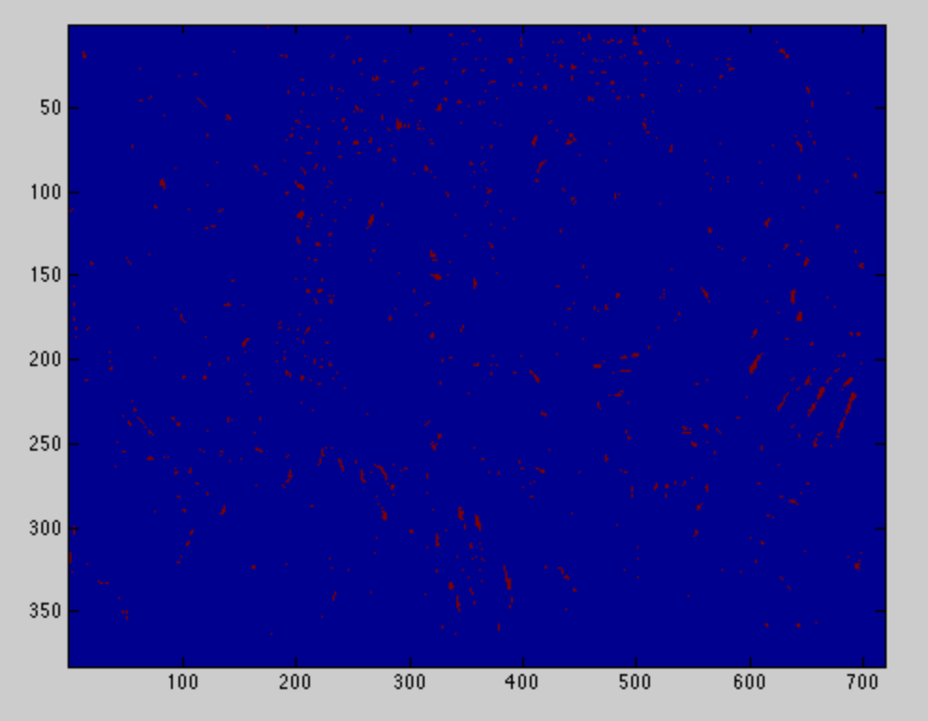

H(X) = 8

The process was repeated for other scales like 0.5 and 0.75 of the original image. The larger scales of 1.5 and 2.0 times were not used as the size of the faces used to scan against is 19x19, which is much smaller than the faces observed at the larger scales. The threshold for the other images were set at 0.8*the maximum, to remove false positives. The resulting detection matrices were then combined with the other scales: p4_img1.mat – p4_img4.mat

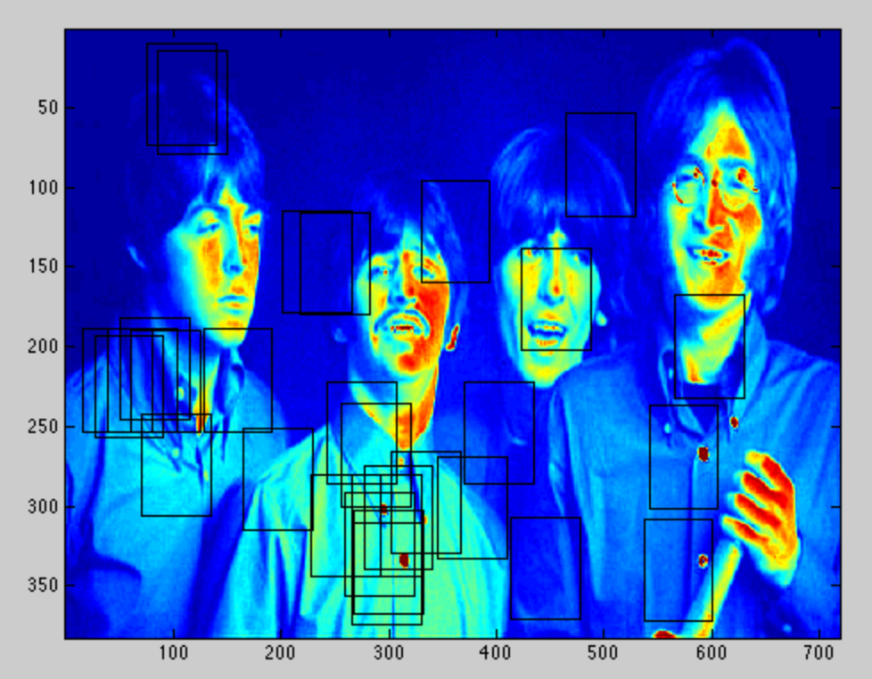

Combining rectangles, the regions of the corners where the faces are detected are labeled with small rectangles. The detection is not very accurate, which agrees with the preliminary testing on the boosting data, where the accuracy for face detection is 60%, just slightly above random, though the accuracy for non-faces is higher, approaching 90%.

(p4_img1.mat)

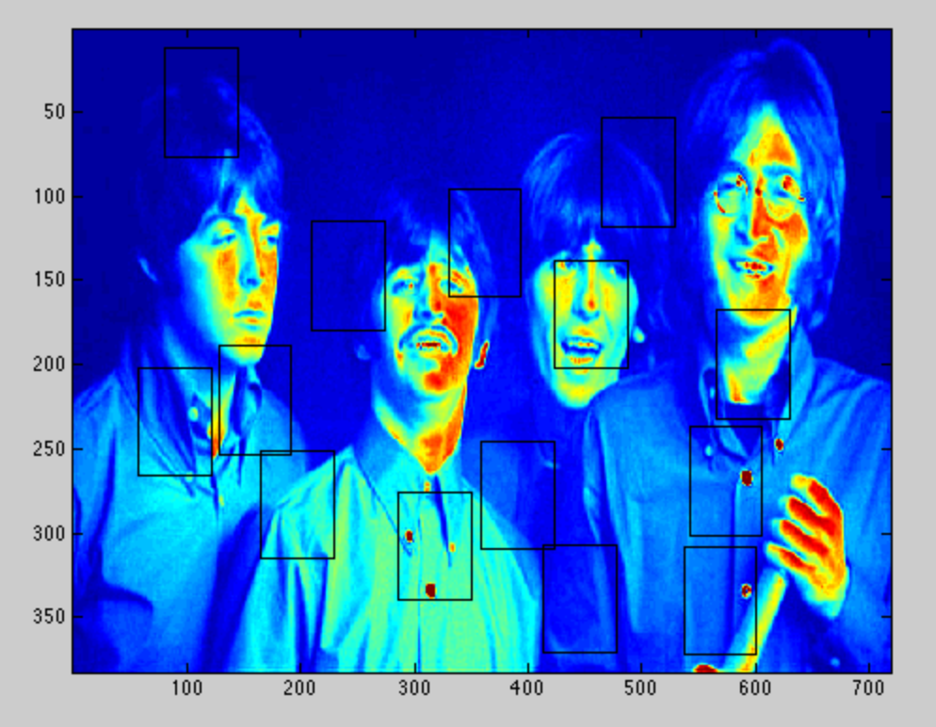

Applying to other images (saved matrices in p4img2.mat):

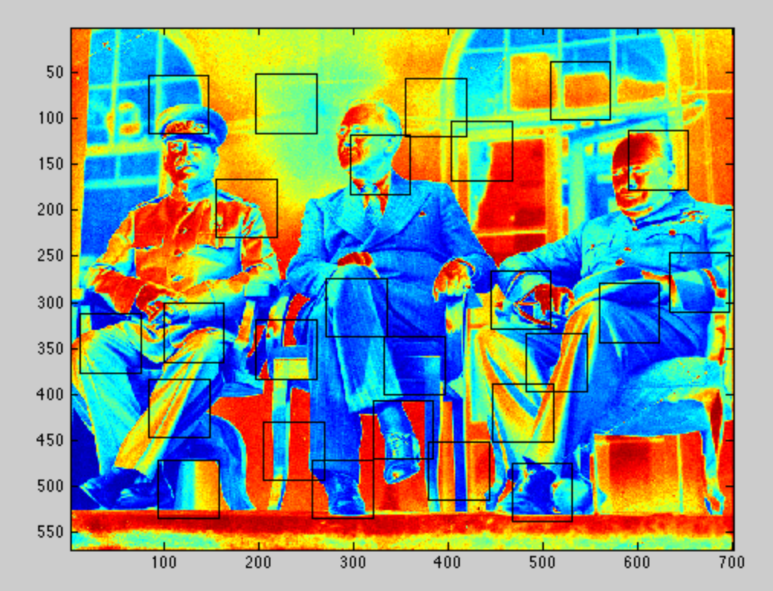

(p4img3.mat)

(p4img4.mat)

